Chapter 5, Problem 17

Calculate the gain v_{o}/v_{i} when the switch in Fig. 5.56 is in: (a) position 1 (b) position 2 (c) position 3.

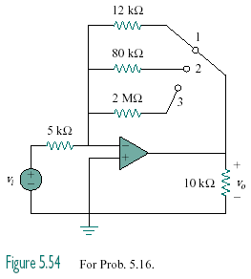
Figure 5.56
For Prob. 5.17.

